Project REPORT

APPLICATION OF (ICT)

Department of METALLARGY AND METERIAL ENGINEERING

Submitted By:
MUHAMMAD MUNEEB
12-3-1-020-2025

DateD:
MONDAY , 4TH MAY , 2026

CREAM SALES USING SARIMA MODEL

Abstract:
This project aims to forecast monthly ice cream sales for the next 12 months by analyzing historical sales data. Using Python and the statsmodels ARIMA library, we built a SARIMA (Seasonal ARIMA) model to predict future sales. We did this by analyzing trends, seasonal patterns, and past monthly fluctuations. The output helps businesses plan production, inventory, and marketing strategies by providing anticipated monthly sales.

Specifications:
We used historical ice cream sales data. By analyzing trends and seasonality, we did the following:
- Predicted monthly sales for the next year.
- Analyzed seasonal effects, such as higher sales in summer months.
- Tracked overall trends in sales over multiple years.
The model we used is SARIMA, chosen because it can handle both trend and seasonal components. We set the ARIMA order to (2,1,2) and the seasonal order to (1,1,1,12). We trained the model on all historical data so we could forecast future months.
Key parameters we considered include:
- Monthly units sold
- Trends over years
- Seasonal cycles captured by the seasonal order

Method:
The method we followed is:
- Import Libraries:
We imported pandas, numpy, matplotlib.pyplot, statsmodels ARIMA, and sklearn metrics including r2 score and mean squared error.
- Load and Visualize Data:
- We loaded ice_cream.csv using pandas and parsed the Date column.
- We set Date as the index and sorted the data using pandas.
- We plotted the full time series with matplotlib to visualize trends and seasonality.
- Train SARIMA Model:
- We initialized the model using ARIMA on the Units Sold column with order (2,1,2) and seasonal order (1,1,1,12).
- We trained the model using the fit function of ARIMA.
- Forecast Future Sales:
- We forecasted the next 12 months using the forecast function of the trained model.
- We created future month indices with pandas date range to match the forecast.
- Prepare Data for Evaluation and Plotting:
- We compared actual sales with the model predictions using fitted values.
- We filtered predictions from 2010 onward to clearly see model performance.
- Plot Historical Data, Predictions, and Forecast:
- We plotted full historical sales using matplotlib.
- We plotted model predictions from 2010 onward with dashed lines.
- We plotted the 12-month future forecast with markers.
- Model Evaluation:
- We calculated R2 score and mean squared error for predictions from 2010 onward to evaluate accuracy.
- Export Results:
- We combined historical sales and forecasted sales using pandas concat.
- We exported the results to a CSV file for further analysis.

Explanation of Code:
User Interaction and Data Collection:
We started by loading historical monthly sales data using pandas. The data included Date and Units Sold. We did this to create a foundation for trend and seasonality analysis.
Data Processing:
We did the following:
- Load and clean data: We sorted the data and ensured it had no missing values.
- Model Training: We trained a SARIMA model using ARIMA on historical sales.
- Prediction: We forecasted the next 12 months using the model’s forecast function.
- Evaluation: We compared predictions with actual sales from 2010 onward using R2 score and mean squared error.

Output:
The program produced:
- Predicted monthly sales for the next 12 months.
- Model evaluation metrics including R2 score and mean squared error.
- Visualizations showing:
  - Historical sales (full history)
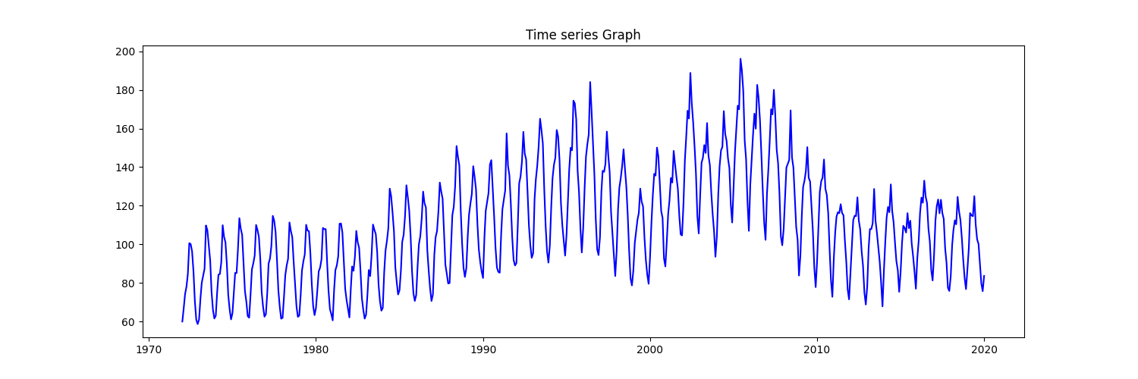
  - Model predictions from 2010 onward
  - Future forecasts

- Time series graph of Ice cream Sales. WE get to know that the graph has very strong seasonality. The High peaks are during the summer months. There is an upward trend till 2000s as sales are increasing. Later on, WE see some decrease in sales overall mostly after 2005s.

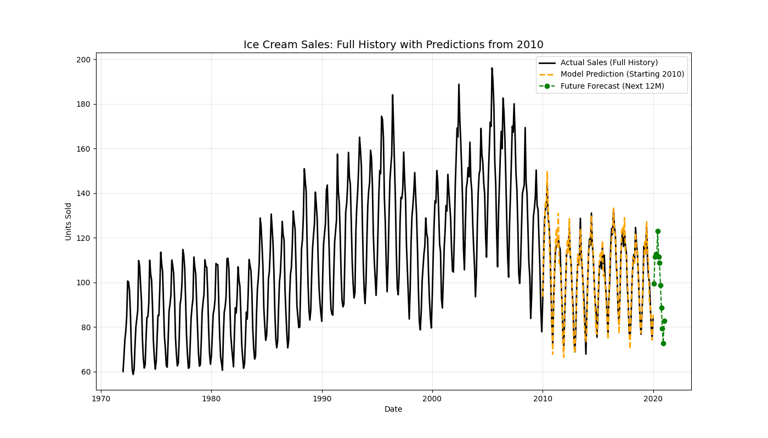

- Here we have the Final output in the form of a graph. The black line are the actual sales. Where orange lines are the predictions of the model and we see how well the model is predicting the values and is very close to the actual sales. The doted green graph is future 12 months prediction and we can see the continuation of trend and no sudden high and low sales.

Training Data:
We used monthly ice cream sales data including Date and Units Sold. We did data preprocessing by sorting dates and ensuring the dataset was complete and ready for SARIMA modeling.

Storing Code on One Drive:
We stored all code and project files on OneDrive. This helped us maintain version control, collaborate easily, and keep backups secure.
OneDrive Link:
https://drive.google.com/drive/folders/139i8FQcd_kiP7KzkplH2tpwCeD92ZWo_?usp=sharing

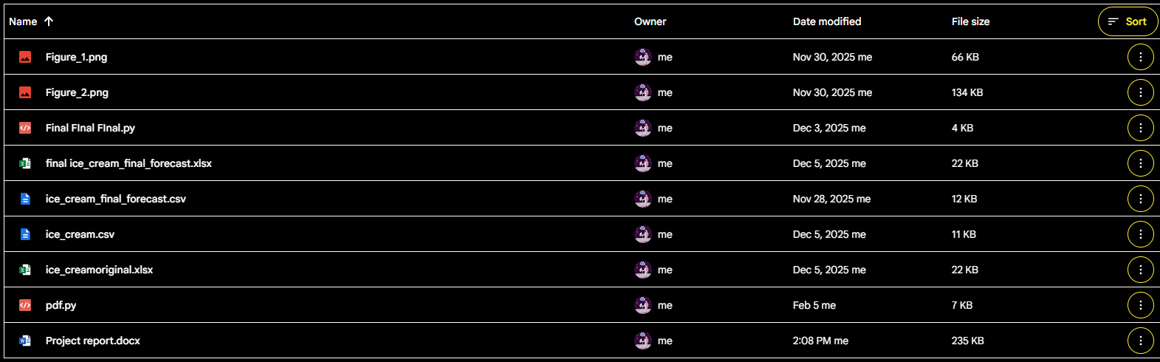

Conclusion:

We successfully built a SARIMA model to predict ice cream sales. We did trend analysis, captured seasonality, and forecasted future sales. This model provides actionable insights for inventory planning, production, and marketing strategies. Using this approach, businesses can anticipate demand and optimize operations based on predicted monthly sales.

